PROJECTS IMPLEMENTATION STATUS IN THE WORKS DEPARTMENT DURING FY 2025/2026
- Releases as of end of September FY 2026/27
S/No | Funding source | Category | Budget | Funds received | Balances
1 | Uganda Road Fund | District | 155,720,344 | 146,013,602 | 9,706,742
1 | Uganda Road Fund | Sub counties | 108,421,392 | 108,421,392 | 0
1 | Uganda Road Fund | Busunju Town Council | 37,632,385 | 35,287,080 | 2,345,305
 | Sub Total URF |  | 301,774,121 | 289,722,074 | 12,052,047
2 | Rehabilitation Grant (MoWT) | District | 1,000,000,000 | 1,000,000,000 | 0
Grand Total |  |  | 1,301,774,121 | 1, 289,722,074 | 12,052,047

- Status of implementation of projects for FY 2025/26
S/No | Project description | Length (km) | Budget | Amount spent | Completion status | Project launching/ data | Source of funding | Scope of works
 | Mechanized routine maintenance Kambuzi-Wabiyinja-Kakindu | 7.9 | 148,905,000 | 123,099,800 | 100% complete | Date: 12/06/26  Road Management Committee members  Nakiyingi Regina  Ssemugenyi Mpiso Robert  Kiyingi Edison  Batte Charles  Lutale Peter  Mutyaba Resty  Kabada Musawo | Maintenance grant | Included Mobilization and demobilization of equipment, bush clearing opening and shaping, and compaction, gravelling works, drainage works
 | Mechanized routine maintenance Kikonge-Kanyanya | 8 | 88,993,000 | 75,453,000 | 100% complete | Date: 7/04/26  Road Management Committee members  Ssebufu John  Ssenyondo Mike  Namubiru Ruth  Byakatonda Peter  Kajabaga Lawrence  Bogere Steven  Lwere Matovu Faluk  Nakitto Florence | Maintenance grant | Included Mobilization and demobilization of equipment, bush clearing opening and shaping, and compaction, filling and raising of Kizikibi swamp gravelling works, drainage works
 | Mechanized routine maintenance Kitongo-Maanyi | 12.2 | 94,568,600 | 94,568,600 | 100% complete | Date:  Road Management Committee members  Mujambi Chrizotom  Kaweesi John  Katdiita Maria  Namayanja Olivia  Ssebunya Moses  Kyobe Posiano  Matovu Joseph  Kizito Nathan  Kyerima David | Maintenance grant | Included Mobilization and demobilization of equipment, bush clearing opening and shaping, and compaction, gravelling works, drainage works
 | Mechanized routine maintenance Kalaalo-Kalangaalo | 14 | 173,977,400 | 173,977,400 | 100% complete | Date: 30/09/25  Road Management Committee members  Ssekyewa Charles  Lugemwa Joseph  Mukamazera Veronica  Bira Gertrude  Ssekitoleko Abud  Ssempewo Edward  Mwebe Robert  Nsubuga Fred  Munyegenye Paul | Maintenance grant | Included Mobilization and demobilization of equipment, bush clearing opening and shaping, and compaction, filling and raising of Kalaalo and Ngonza swamps, gravelling works, drainage works
 | Mechanized routine maintenance Kasanda boarder-Kyamusisi-Magala boarder | 9.8 | 72,837,700 | 62,137,700 | 100% complete | Date: 20/05/26  Road Management Committee members  Menge Deo  Kibuga Elusama  Ssekutte Moses  Kiberu Geofrey  Lule John  Dezirata Mulemu  Balanya Tadeo  Ssempira Swaibu  Kamya Peter  Wasswa Moses | Maintenance grant | Included Mobilization and demobilization of equipment, bush clearing opening and shaping, and compaction, gravelling works, drainage works
 | Mechanized routine maintenance Kigogolo swamp | 1.8 | 62,909,000 | 62,909,000 | 100% complete | Date: 16/3/26  Road Management Committee members  Ssekanjako Ronald  Mwajje Samuel  Kyanbadde Charles  Nakamatte Annet  Matovu Abbey  Nantume Ruth Nabulya  Ssebuliba Sudaisi  Bbaale Ashiraf  Kawoya Abubakar | Maintenance grant | Included Mobilization and demobilization of equipment, bush clearing opening of the swamp and shaping, and compaction, and drainage works
 | Mechanized routine maintenance Kasenyi-Mpirigwa | 10.5 | 62,769,200 | 59,139,200 | 80% | Date: 3/7/26  Road Management Committee members | Maintenance grant | Included Mobilization and demobilization of equipment, bush clearing opening and shaping, and compaction, gravelling works, drainage works
 | Mechanized routine maintenance Matte and Fululu swamp | 0.7 | 38,500,000 | 35,401,800 | 100% complete | Date:  Road Management Committee members  Lwebuga Emma  Mulindwa Robert  Kalyango Fedrick  Bussa Luke  Muwanga Dirisa  Kwagala Betty  Nakanwagi Christine  Bukenya Hammed  Nyanzi Fedirck | Maintenance grant | Included Mobilization and demobilization of equipment, bush clearing opening and shaping, and compaction, filling of both Fululu and Matte swamps and drainage works
 | Mechanized routine maintenance Kyakosi-Katiti-Katungulu-Nakiragala-Budimbo-Kikunyu | 19.1 | 135,367,200 | 135,367,200 | 100% complete | Date: 11/10/25  Road Management Committee members  Yisiko Twaha  Kiyimba Faluku  Tudeka Muhamed  Kalimu Lubwama  Buying Patrick  Dala Numan  Epafula Lukwago  Sseruyage Abdul Kalim  Swalid Bahizi  Ssefubwe Vicent | Maintenance grant | Included Mobilization and demobilization of equipment, bush clearing opening and shaping, and compaction, gravelling works, drainage works
 | Emergencies | 5 | 21,172,900 | 21,172,900 | 100% of the funds used |  | Maintenance grant | Works so far done include Ddundu-Namasenene, emergency works along Namudaali swamp, emergency works for roads during the president’s visit and extra culverts along Bulera-Kiryokya, extra culverts along Fululu and Matte swamp.
 | Administrative Costs
 | Mechanical Imprest |  | 100,000,000 | 100,000,000 | Q1, Q2 and Q3 expenditures on repairs for the wheel loader, roller and serviced grader |  | Maintenance grant | Repaired wheel loader, roller and serviced grader
 | Sub Total Rehabilitation grant | 88.7 km | 1,000,000,000 | 1,000,000,000
 | Uganda Road Fund
 | Mechanized routine maintenance Nakwaya-Kabulamuliro | 7.8km | 79,913,000 | 72,975,880 | 80% complete | Date: 9/07/26  Road Management Committee members  Ssekitto Geofrey  Buyondo Aloyzious  Kasenere Henry  Kaggudde Joseph  Twaha  Nakabugo Annet  Ssebagala Henry  Nanteza Mary  Mutebi Christopher | URF | Included Mobilization and demobilization of equipment, bush clearing opening and shaping, and compaction, gravelling works, drainage works
 | Mechanized routine maintenance of Ndoge-Nakaziba | 4.3km | 15,963,695 | 15,363,696 | 100% complete | Date: | URF | Included Mobilization and demobilization of equipment, bush clearing opening and shaping of the road section.
 | Manual routine maintenance | 282.2 km | 68,799,929 | 47,655,000 | Works for the months of November and April. |  | URF | Gangs were deployed and works done for the FY 25/26 and paid the workers for the months of November and April.
 | Maintenance of Subcounty roads | 29 km | 108,421,392 | 108,421,392 | Funds transferred as received |  | URF | Funds transferred as received
 | Transfers to Busunju TC | 3.8 km | 37,632,385 | 35,287,080 | Transferred Q1, Q2 and Q3 road maintenance funds to Busunju TC |  | URF | Funds transferred works not yet started
 | Administrative costs
 | Administrative costs |  | 2,000,000 | 2,000,000 | Funds spent as received |  | URF | Funds spent as received
 | Allowances |  | 1,550,870 | 1,550,870 | Paid allowances to staff in works department for Q1, Q2, Q3 and Q4. |  | URF | Paid allowances to staff in works department for Q1, Q2, Q3 and Q4.
 | Departmental Fuel |  | 3,456,545 | 3,456,545 | Funds spent as received |  | URF | Funds spent as received
 | Sub Total URF |  | 301,774,121 | 289,722,074
Complied by

Katende Jack
District Engineer

PHOTOS OF THE WORKS DONE

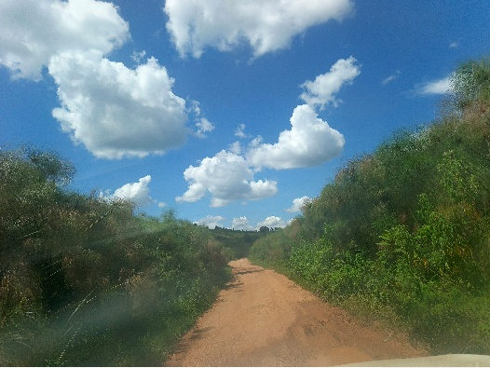 | 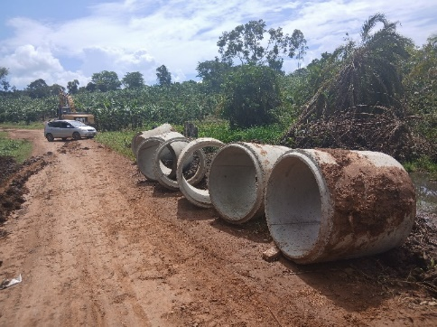
 | Kyamusisi
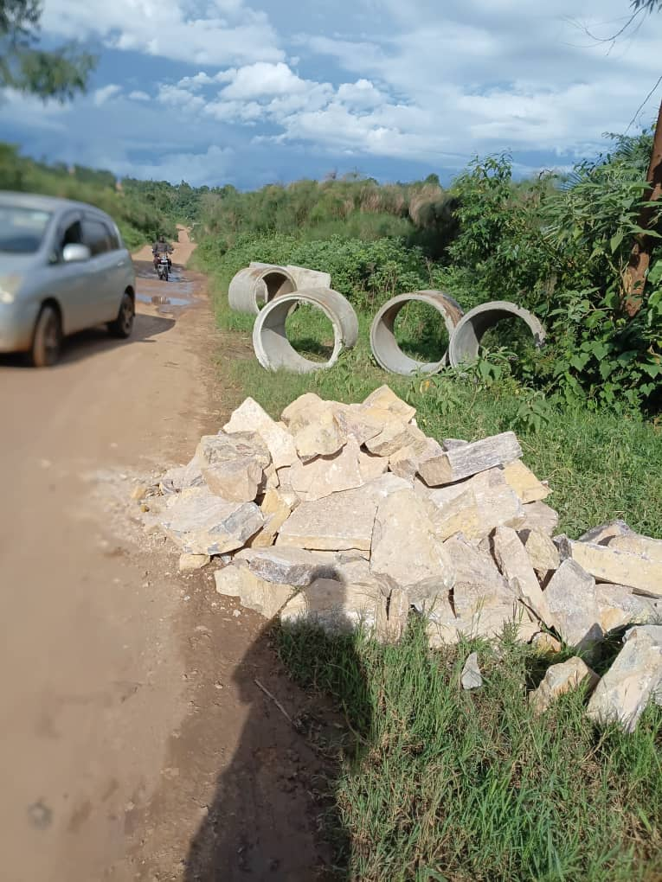 | 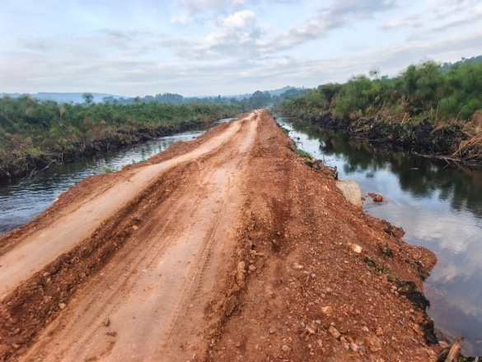
Fululu and Matte before rehabilitation | Fululu and Matte during rehabilitation
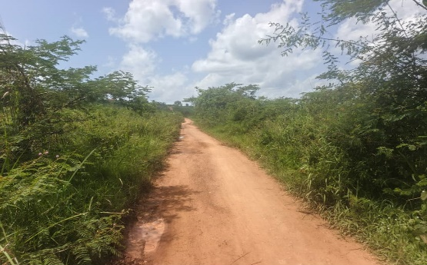 | 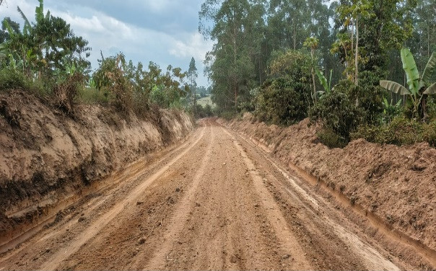
Kikonge-kanyanya road before rehabilitation | Kikonge-kanyanya road during rehabilitation
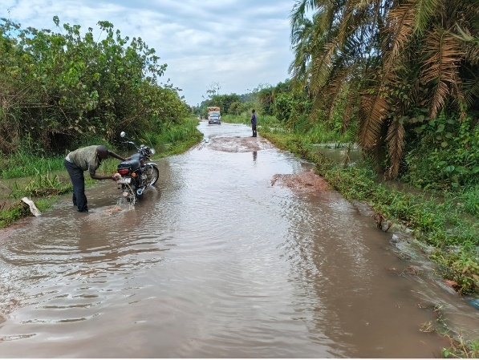 | 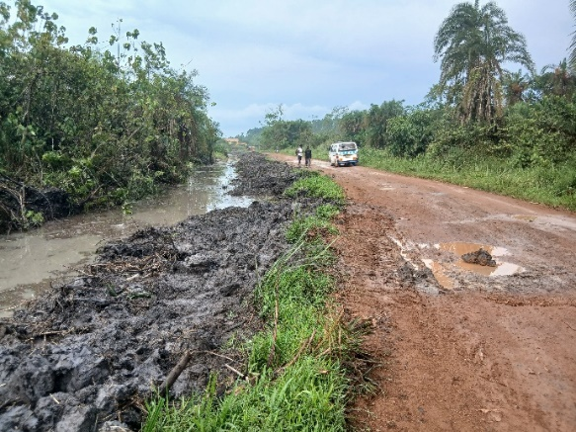
 | Kalaalo swamp after during opening
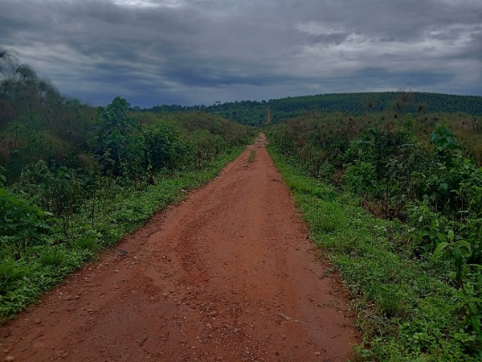 | 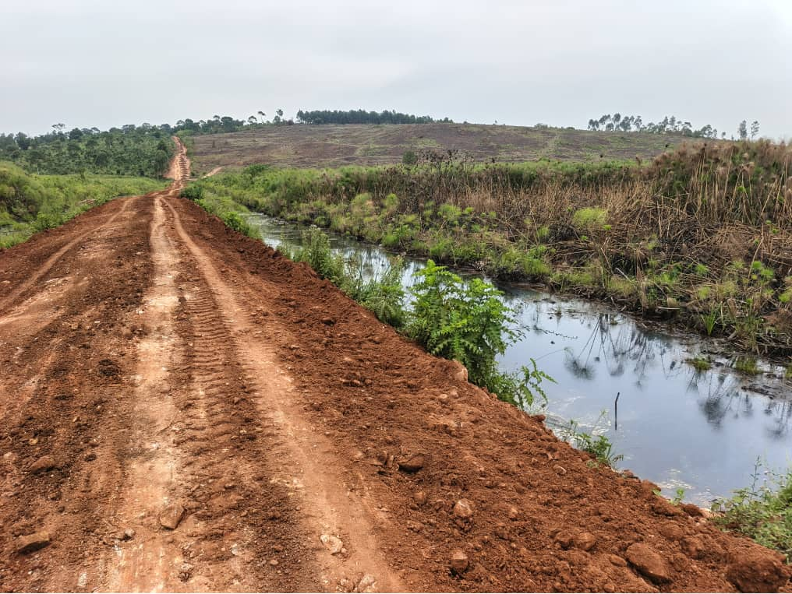
Kigogolo Swamp before rehabilitation | Kigogolo Swamp after rehabilitation
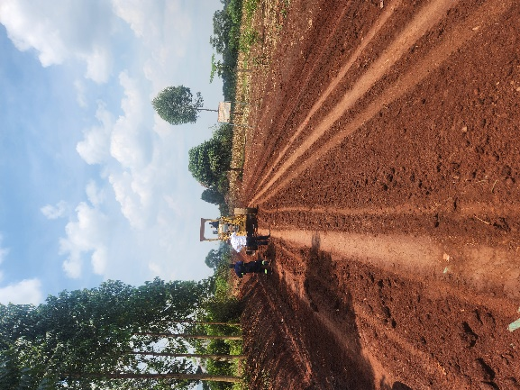 | 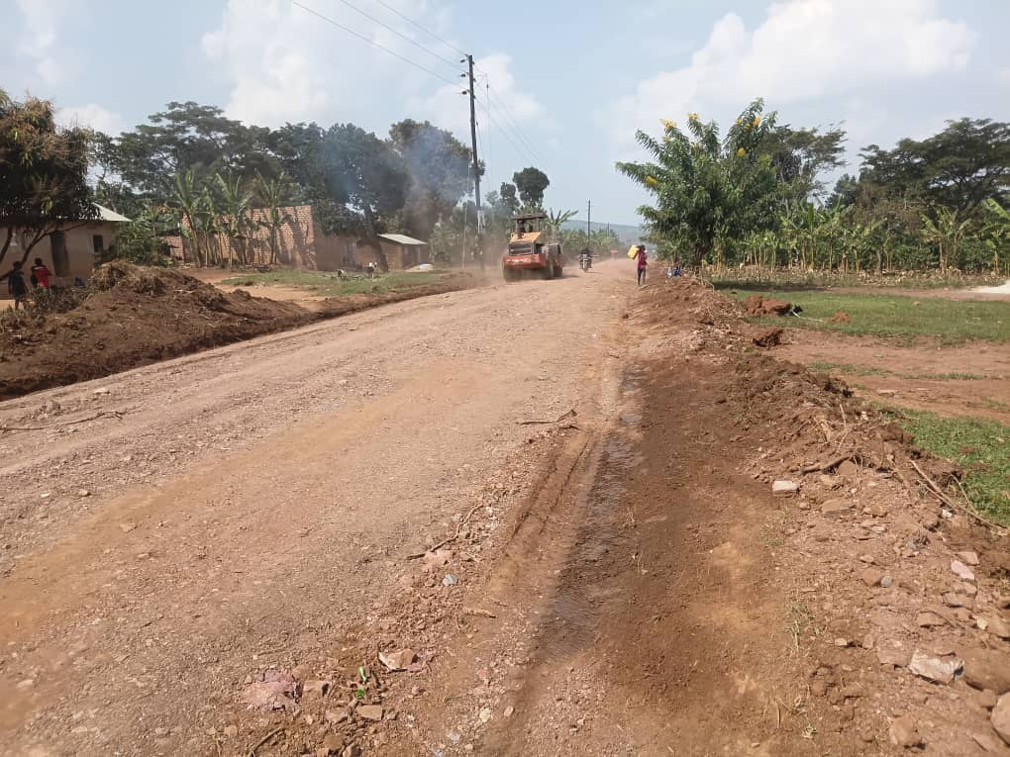
Works along Nakwaya-kabulamuliro | Completed section along Nakwaya-Kabulamuliro
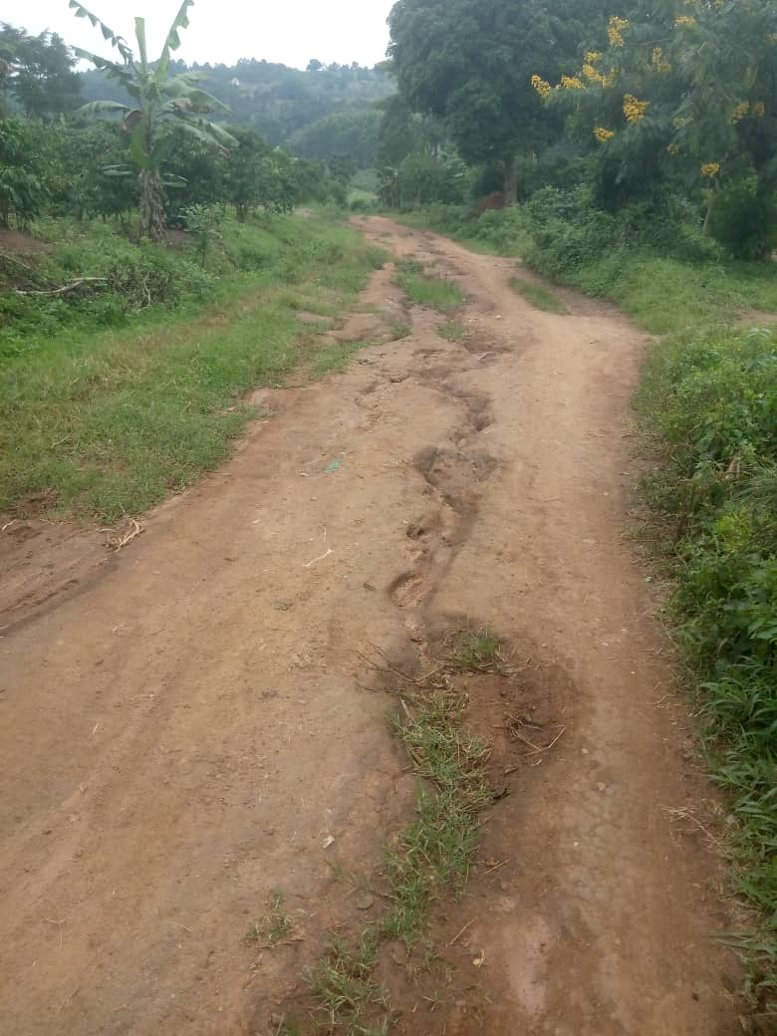 | 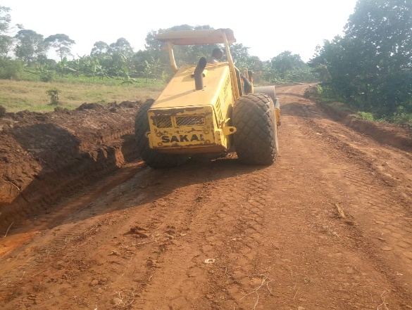
Section of Kyakosi-Nakilagala-Bidimbo-Kikunyu road before rehabilitation. | Section of Kyakosi-Nakilagala-Bidimbo-Kikunyu road during rehabilitaion.
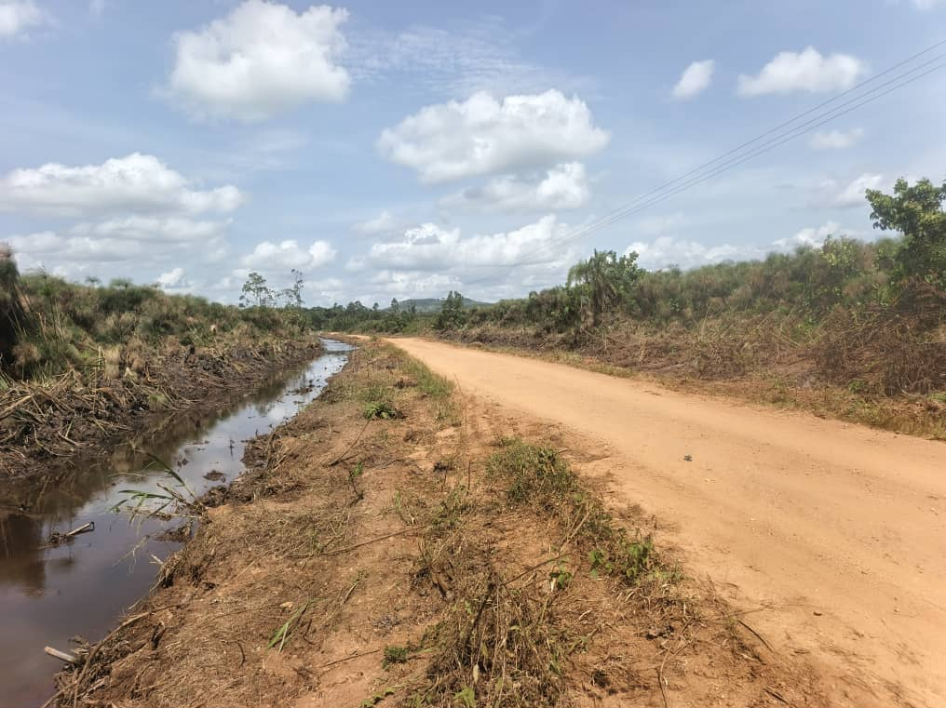 | 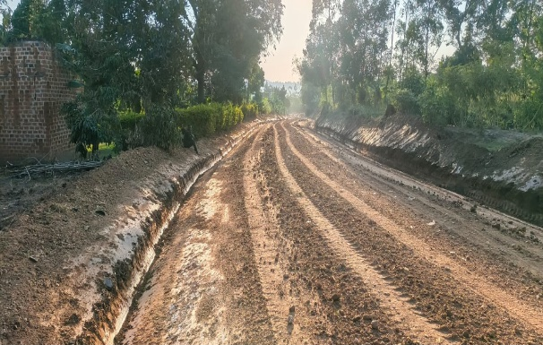
Section of Kambuzi-Wabiyinja-Kakindu road durig rehabilitation (opening of swamp) | Section of Kambuzi-Wabiyinja-Kakindu road durig rehabilitation

